ICAC Moral Education e-Book
《Daisy’s Stored-value Card》

Name: _______________________ Class: ____________ ( ) Date:__________________

Multiple Choice Questions
Please write your answers in the space provided.

1. What did Floral Fairy give Daisy as a birthday present?
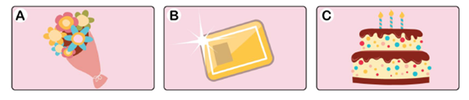 | Answer:  B
2. Where did Daisy go with her friends?
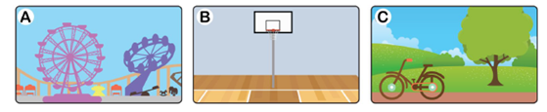 | Answer:  A
3. Who told Daisy that she had no more money to spend?
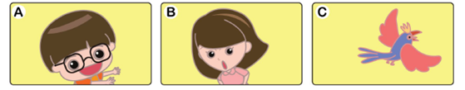 | Answer:  C

Colouring
Daisy decided not to spend money in a casual way. Floral Fairy gave Daisy a Piggy Bank to save money. Please help Daisy to colour the Piggy Bank and suggest how she can make use of the money to help the needy.
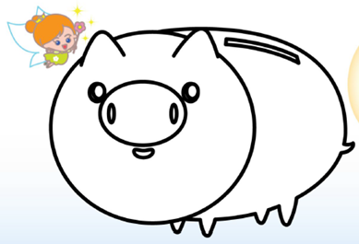

I would like to use my savings to help others by __making donations to some _charitable organisations.____

ICAC Moral Education e-Book Website: http://www.me.icac.hk/icac/ebook2015/en/index.html

