ICAC Moral Education e-Book
《Block Castle》

Name: _______________________ Class: ____________ ( ) Date:__________________

Recount
Was Henry well-behaved in school? Give a recount of Henry’s behaviours. Draw a picture to show what was happening and indicate if this was a good or bad behaviour.
 |  |  | Good () / Bad () behaviour?
example | 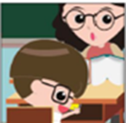 | Henry played with the phone during lesson.
_Henry ate snacks and behaved rowdily on
_the school bus. ______________________
 | 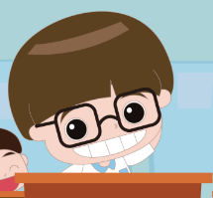 | _Henry always failed to observe discipline_  _in class and made jokes on everything. __

Joining the Dots
Henry has become a disciplined boy. He is queuing up with his classmates. Do you know what they are waiting for? Try to find the answer by connecting the dots in sequence.
Answer: Ferry
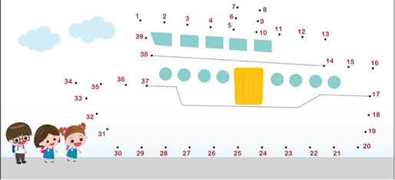
ICAC Moral Education e-Book Website: http://www.me.icac.hk/icac/ebook2015/en/index.html

