ICAC Moral Education e-Book
《The Real Test》

Name: _______________________ Class: ____________ ( ) Date:__________________

Story Re-writing
Jack made the right decision to hold back from cheating in the English Test. What would happen if he had really cheated? Try to re-write the story according to the pictures below.
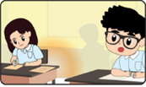 | Time is running out! Jack decided to copy Maggie’s answers onto his own answer sheet!
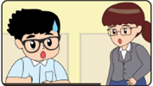 | When Jack looked up, Ms Chan was just standing next to him!__________________ _____________________________________________________________________
Maggie knew that Jack had cheated in the test. She __________________________
_____________________________________________________________________
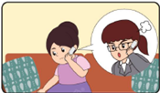 | Mother received a call from the teacher. ______________________________________  ____________________________________________________________________________  Jack was full of regret. He apologised to mother, the teacher and his classmates.

Spot the Differences
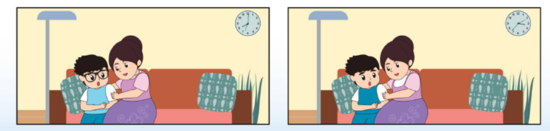
There are FIVE differences between the two pictures below. Try to spot and circle them.
ICAC Moral Education e-Book Website: http://www.me.icac.hk/icac/ebook2015/en/index.html

