ICAC Moral Education e-Book
《The Real Test》

Name: _______________________ Class: ____________ ( ) Date:__________________

Story Re-writing
Jack made the right decision to hold back from cheating in the English Test. What would happen if he had really cheated? Try to re-write the story according to the pictures below.
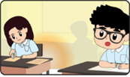 | Time is running out! Jack decided to copy Maggie’s answers onto his own answer sheet!
 | When Jack looked up, Ms Chan was just standing next to him! She was very____ disappointed and told Jack to see her after class. ____________________________
 | Maggie knew that Jack had cheated in the test. She was very angry about it. Jack apologised for it but Maggie was too upset and ran away. _____________________
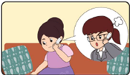 | Mother received a call from the teacher. _She apologised for Jack’s behavior and agreed that he should receive punishment so that he could learn about the importance of integrity.  Jack was full of regret. He apologised to mother, the teacher and his classmates.

Spot the Differences
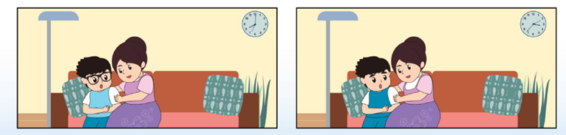
There are FIVE differences between the two pictures below. Try to spot and circle them.
ICAC Moral Education e-Book Website: http://www.me.icac.hk/icac/ebook2015/en/index.html

