ICAC Moral Education e-Book
《The Extraordinary Runner》

Name: _______________________ Class: ____________ ( ) Date:__________________

Thank You Letter
Imagine you were Lenny / Fred and write a letter to express your gratitude to your teammate.

Dear ___________,

Thank you for ________________________________________________
__________________________________________________________________________________________________________________________________
_________________________________________________________________
Regards,

____________

Maze Game
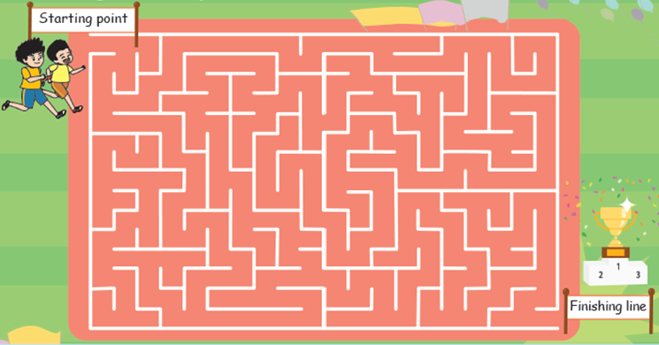
As Fred’s guide runner, please lead him to run out of the maze!
ICAC Moral Education e-Book Website: http://www.me.icac.hk/icac/ebook2015/en/index.html

