ICAC Moral Education e-Book
《Class Monitor Election》

Name: _______________________ Class: ____________ ( ) Date:__________________

Right or Wrong?
Which of the following behaviours support clean election? Put a tick in the space provided. For wrong-doings, put a cross in the space provided.

Tom treated his classmates with snacks in return for their votes. |  | All the classmates declined Tom’s offer of snacks and refused to vote for him. |  | Students voted for Howard because he was competent and was ready to serve. |  | Tom overstated the contribution he had made for the class.

Word Search Puzzle
ICAC Moral Education e-Book Website: http://www.me.icac.hk/icac/ebook2015/en/index.html

Fair elections should be based on capabilities. Any attempt to win by inappropriate means would be unacceptable!  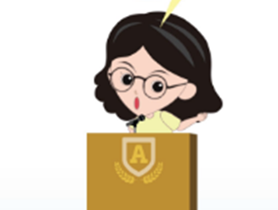  Please invite your parents to show support to clean and fair election by putting a “tick” in the space provided. | Can you circle the words “FAIR” and “ELECTION” in the following puzzle? (Hint: Each word appears 3 times in the puzzle.)
 | 