ICAC Moral Education e-Book
《The Lost Eraser》

Name: _______________________ Class: ____________ ( ) Date:__________________

Story Sequencing
Try to arrange the following pictures according to the order of events in the story.
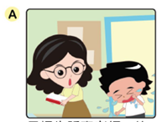 |  | 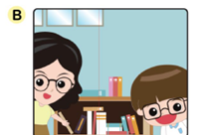 |  | 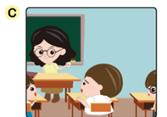
Tom told Miss LI that he had lost his eraser. |  | To make up for his mistake, Henry helped Miss LI tidy up the bookshelves. |  | Miss LI told the class to help search for Tom’s eraser.
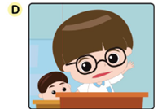 |  | 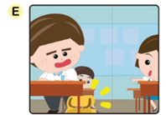 |  | 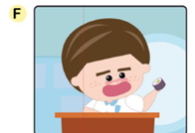
Henry confessed that he took Tom’s eraser. |  | Kitty found the eraser in Simon’s school bag. |  | Simon said he didn’t take Tom’s eraser.

The order of events should be：
1. ( ) 2. ( ) 3. ( ) 4. ( ) 5. ( ) 6. ( )

Colouring
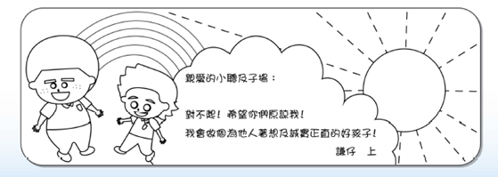
Henry would like to send a bookmark to his classmates to apologise for what he did and commit to be an honest and considerate boy. Would you colour the bookmark below designed by Henry?
ICAC Moral Education e-Book Website: http://www.me.icac.hk/icac/ebook2015/en/index.html
Dear Tom and Simon,
I am really sorry! Please forgive me! I promise to be an honest and considerate boy from now on!
Henry

