ICAC Moral Education e-Book
The Election

Name: _____________________ Class: ___________ ( ) Date:__________________

Crossword Puzzle
Complete the crossword puzzle below using the vocabulary words in the story.
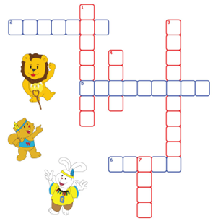

Down
1. The animal tribe was holding an ______ for their chief.
3. Lion King and Crocodile Head are the two ______ of the election.
4. Walala was impressed by Lion King’s speech and decided to ______ for him.
7. We should support a ______ election based on real capabilities.

Across
2. Lion King was a very ______ leader. He often helped the tribe members to solve problems.
5. Walala thought that Crocodile Head did not have real ______ and leadership.
6. Crocodile Head gave free ______ to the animals in order to gain their votes.

Maze Game
Try to get out of the maze by avoiding the gifts offered by Crocodile Head.

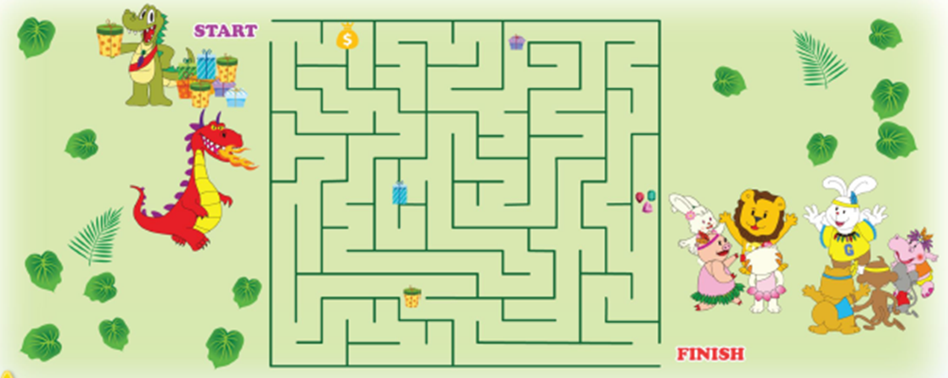
After completing the worksheet, please invite your parents to put a ‘' in the space provided in support of a clean and fair election.

