ICAC Moral Education e-Book
Answers
Mai Po Visitors

Name: _____________________ Class: __________ ( ) Date:_________________

Do’s & Don’ts
Describe what the animal kids are doing. Put a ‘’ in the box if you think the behavior is correct, and a ‘’ if it is incorrect.

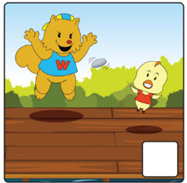 | 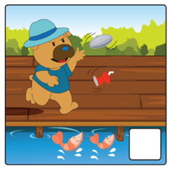 | 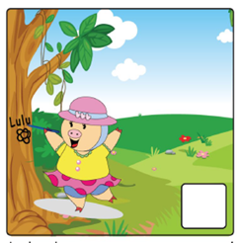
Chickeebee and Walala ran and chased one another on the boardwalk. They shouted and laughed loudly. | Dingy Dog threw stones and littered into the shrimp pond. | Lulu drew graffiti and carved words on the tree trunks.
Fill in the Table
Have you ever seen the following signs? Please state in the table below where these signs can be found and the meaning of these signs.

 | Signs | Place(s) where the sign can be found | Rules
Example |  | Parks | No flower picking
1 | 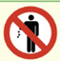 | Parks, beaches, etc. | Don’t litter
2 | 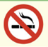 | Cinemas, restaurants, etc. | No smoking
3 | 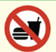 | Buses, MTR, libraries, etc. | No food or drinks / eating
4 | 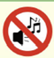 | Libraries, cinemas, concert halls, etc. | Keep quiet

