ICAC Moral Education e-Book
Answers
Pocket Money

Name: _____________________ Class: ___________ ( ) Date:__________________

Fill in the Blanks & Story Sequencing
Describe the events shown in the pictures below by filling in the blanks. Write down 1, 2, 3 or 4 in the boxes to show the correct sequence of the story.

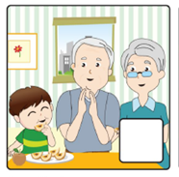  3 |  | 2 |  | 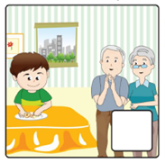  4 |  | 1
Grandfather peeled and sliced the pears for Timmy. |  | Timmy suggested to help doing housework and asked grandmother to give him five dollars / money in return. |  | Timmy helped Grandparents to clean up the peels on the table. |  | Grandmother served Timmy a bowl of Chinese soup.

Is Money Almighty?
Try to identify which of the following items can / cannot be bought with money by putting them into the table below.
Time Mobile phone Clothes
Love Stationery Friendship
Snacks Wisdom Watch
Health Toys Trust

Things which CAN be bought with money | Things which CANNOT be bought with money
Snacks, Mobile phone, Stationery,  Toys, Clothes, Watch | Time, Love, Health,  Wisdom, Friendship, Trust

Do you think ‘money is almighty’? Why?
Money is NOT almighty. Money is essential for living but it is only part of our life. There are many things which money cannot buy, for example, health, love, happiness and friendship.

