ICAC Moral Education e-Book
Answers
The Time Detective

Name: _______________________ Class: ____________ ( ) Date:________________

Fill in the Blanks
What are the consequences if Tommy did not manage his time well? Fill in the blanks using the vocabulary words in the story.
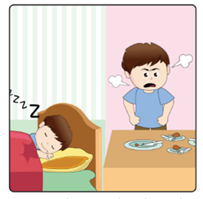 |  | 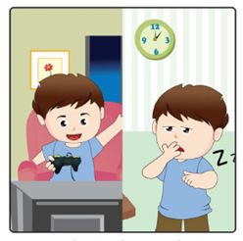
Tommy took a nap and was late at his friend’s birthday party. He wasted his own and others’ time since he was not punctual. |  | Tommy kept playing electronic games and did not go to sleep until very late.  He could not finish his homework and was late to school. |  | Tommy was late for the school’s sports day. Tommy’s relay team was disqualified and lost the game. His team members no longer trusted him.

Can you give Tommy a suggestion to be punctual?
Tommy can prepare a time-table, wear a watch, use a diary to write down things to do, etc.__________
Word Search Puzzle
Tommy used to waste time and fail to keep his promise. Now, he learnt to be P_ _ _ _ _ _ _ and T_ _ _ _ _ _ _ _ _ _ .
Can you circle these two adjectives in the ‘word search puzzle’ and cross out their opposites ‘LATE’ and ‘UNRELIABLE’?

(Hint: each of these 4 words appears 2 times in the puzzle).

