廉政公署德育電子故事書
答案
《噹噹的儲值錢卡》

姓名: ________________________ 班別: ____________ ( ) 日期:__________________

選擇題
請把各題的正確答案，寫在適當的空格內。

1. 花仙子送了甚麼給噹噹?
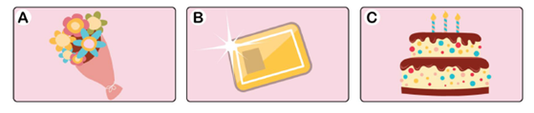 | 答案:  B
2. 噹噹約同學到哪裡玩?
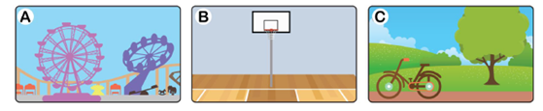 | 答案:  A
3. 噹噹胡亂花錢後，誰通知她儲蓄銀行已沒錢可用?
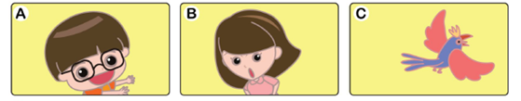 | 答案:  C

填色遊戲
噹噹下定決心不再胡亂花錢，花仙子送了她一個儲蓄錢箱。請你為這個錢箱填上顏色，並建議噹噹怎樣用儲蓄幫助有需要的人。(同學可自行創作，答案只供參考)

我希望用儲蓄幫助有需要的人，我可以 買旗、捐助慈善機構……

