廉政公署德育電子故事書
答案
《抵抗心魔》

姓名: ________________________ 班別: _______________ ( ) 日期:_____________________

故事改編
子傑面對艱深的試卷，腦海閃出作弊的念頭，幸好他臨崖勒馬，成功抵抗心魔! 假如子傑最後選擇作弊，結局會變成怎樣? 試根據下方提示，續寫故事的結局。 (同學可自由創作，答案只供參考)
試發揮你的創意，為子傑提供一個方法，幫助他日後再遇到心魔時可即時將它擊退：
在筆盒上貼著「知恥近乎勇」，以後想犯規時都銘記今次的教訓，三思而後行

 | 沒有時間了，子傑左右張望，趁沒有人留意之際，急忙地把欣彤的答案抄到自己的試卷上!
 | 這時，陳老師發現子傑作弊，十分失望。她示意子傑先完成試卷，但課後須立刻到教員室見她。
 | 欣彤知道子傑抄自己的答案，覺得子傑的行為很要不得，更辜負了她的鼓勵。子傑嘗試向欣彤道歉，也不被理睬呢！
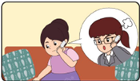 | 媽媽接到老師的來電，她先向老師道歉，並同意子傑應該受到懲罰。子傑回家後，媽媽和他細心傾談，告訴他誠實的人格遠比測驗取得好成績更重要!  子傑感到十分後悔，向媽媽、老師和同學衷心道歉。
找不同
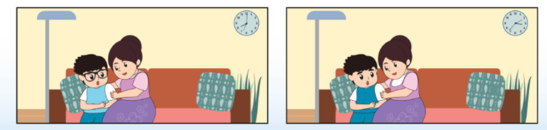
左右兩張圖中有5處不一樣的地方，請找一找，把它們圈出來。

